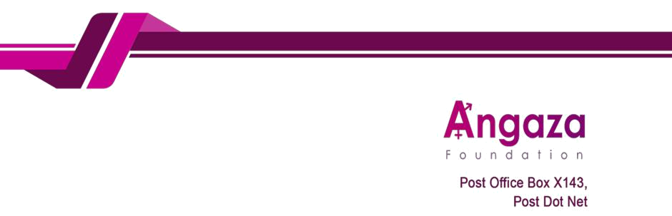

26th September

To: The Bank Manager FDH

Bank

Umoyo Branch of

Blantyre

Dear Sir/Madam,

Subject: Instruction to Funds from USD 1860100042935 Account to MWK accounts

We hereby instruct you to transfer funds from our USD account 1860100042935 to MWK account as detailed

below.

- Exchange rate as today: 1,751

- Receiving accounts detail:

Account name | Account number | Bank | Amount | Currency
Godfrey Kambewa | 9100006366519 | Standard | 413 | Kwacha
 |  | Bank
Mathews James | 1006483166 | National | 365 | Kwacha
 |  | Bank
Doreen Mwenelupembe | 1011556918 | National | 370 | Kwacha
 |  | Bank
Stephen Mdala | 1520000120976 | FDH | 231 | Kwacha
Austin Mdala | 1250000085936 | FDH | 238 | Kwacha

Purpose of transfer: This transfer is payment of salaries for the salaries of September 2025.

Thank you for your prompt assistance with this matter. For any queries, please contact me on +265 996 263 843 or godfreychifuniro@gmail.com

Your Faithfully,


Godfrey Kambewa

Executive Director
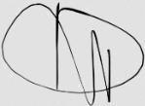

Doreen Mwenelupembe

Programs Manager

